DressingUp Design Specification

Ying Sun  
Electronical Engineering  
Concondir UniversityMontreal, Canada  
[3291676339@qq.com](mailto:3291676339@qq.com)

Shaoxia Yang  
Electronical Engineering  
Concondir UniversityMontreal, Canada  
[shaoxiay@gmail.com](mailto:shaoxiay@gmail.com) Yanhe Lan  
Electronical Engineering  
Concondir UniversityMontreal, Canada  
[yilia.lan@gmail.com](mailto:yilia.lan@gmail.com)

Sijie Min  
Electronical Engineering  
Concondir UniversityMontreal, Canada  
[ellian98765@gmail.com](mailto:ellian98765@gmail.com)

*Abstract*—This document is to be used by the software engineering team to design one software application DressingUp. It will also be used by other design groups to understand the functions of the design in detail. It includes user stories, requirements, task distribution, design timeline and detailed function design etc.

Keywords—software engineering, ICDE system, system requirements, user requirements, database, capture pictures

# Introduction

This document will be used by the software engineering team to design one software application DressingUp. It will also be used by other design groups to understand the function of the design in detail. It includes user stories, requirements, task distribution, design timeline and detailed function design etc.

# icde system and system and user requirements

## problem statement

Many people don't know how to dress themselves up when encounter some special occasions, for example dating, party and other activities etc. They need one method to help them to solve their clothes matching problems.

## System architecture(ICDE system)

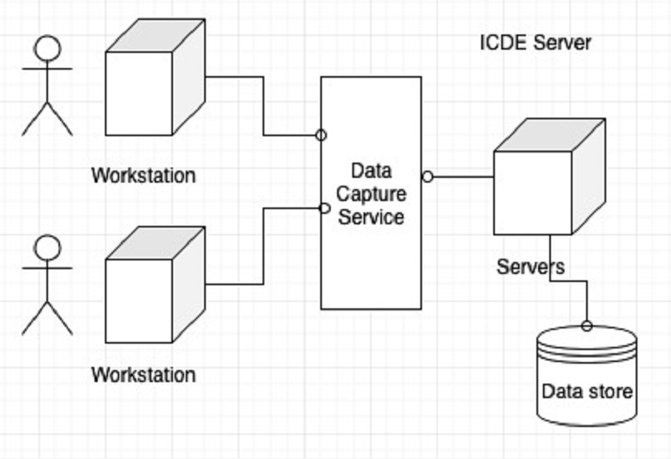

Fig. 1

## Project goal

This project is to design one software application which can help users match their clothes matching and give them some useful recommendations. This software application mainly contains user register and login, capture pictures from other websites, save captured pictures and user data into database and users like and favorites etc. Below figures are the main functions.

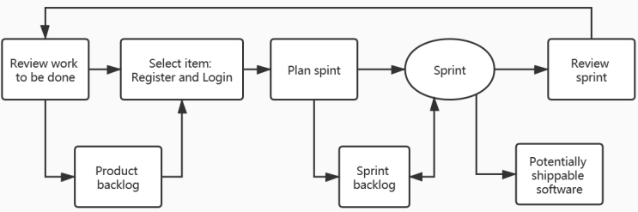

Fig. 2

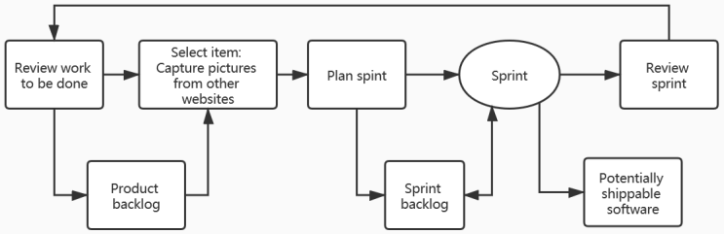

Fig. 3

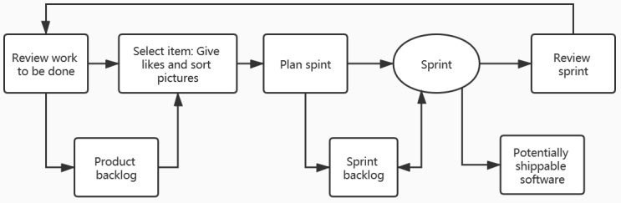

Fig. 4

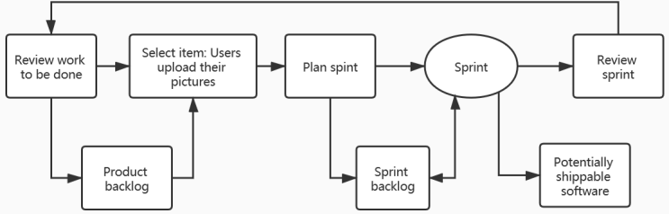

Fig. 5

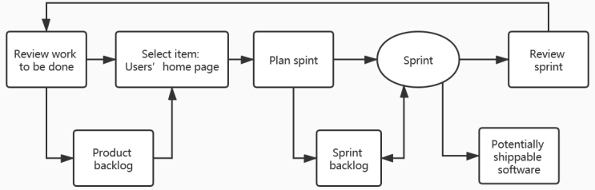

Fig. 6

## User stories

Lily has a date in the weekend and she wants some help on her dressing and match.

First, she registers her account on the DressingUp software application and enters her basic information.

Second, she can choose the appropriate occasions: "date", "party", "company" "school", and so on. If she chooses a scene, she will be asked if she needs a "whole match recommendation" or "only accessories recommendation".

Third, if she chooses "overall match recommendation", the system will recommend a few suitable combinations for her based on the information stored in the database or some matches uploaded by other users. She can like the match ingested and will automatically add it to her favorites. If she has a favorite item, clicking on the picture system will jump directly to the product website to help her get product information.

Forth, if she chooses "only recommend accessories", she will be asked to get a photo of her clothes, and she can choose to take a photo or choose to upload an image. She will be recommended for appropriate accessories based on the clothing information she uploads.

She can also click on the details of the product.

This satisfactory result will be saved after the end of the selection.

## system requirements

* SR1 Build a cloth match recommendation application which lets users have individual accounts, upload pictures, search for desired matches and give ‘like’ or ‘collect’ tags to the pictures, which runs in Android system like a mobile phone.
* SR2 Collect and store users’ activities including manage account information, upload new picture, choose searching keyword and give ‘like’ or ‘collect’ tags to the picture.
* SR3 Develop two databases, one is for storing users’ information, the other is for storing pictures and their information.
* SR4 Count ‘like’ numbers that users give to one picture and save the date to the picture information, and give out high-number items when users search.

## user requirements

* UR1 Access an application which can share pictures and search for desired match recommendations. Press ‘like’ button for the pictures and make private collection.
* UR2 Use this app to manage users’ accounts, share pictures, search for desired pictures and give “like” to them.
* UR3 Search with conditions keywords such as working, party and hang-out etc. And manage account information include my collection.
* UR4 Build a more user-friendly app that can give out popular pictures first.

## Task divide and distribution

### Sub task 1

|  | Register and Login | | |
| --- | --- | --- | --- |
| detail | requirement | designer |
| Task 1 | Register page | SR1 | Yanhe Lan |
| Task 2 | Login page | SR1 | Yanhe Lan |
| Task 3 | User page | SR1,UR2 | Yanhe Lan |
| Task 4 | User information data base | SR3,UR3 | Ying Sun, Yanhe Lan |

### Sub task 2

|  | Capture dressing match pictures from other websites | | |
| --- | --- | --- | --- |
| detail | requirement | designer |
| Task 1 | Selection tags on user page | SR2, UR1 | Sijie Min |
| Task 2 | Pictures show page | SR2, UR1 | Sijie Min |
| Task 3 | Capture dressing match pictures | SR2, UR1 | Ying Sun, Shaoxia Yang |
| Task 4 | Set up data base of dressing match pictures | SR3, UR1 | Ying Sun, Shaoxia Yang |
| Task 5 | Save captured pictures into data base | SR3 | Ying Sun, Shaoxia Yang |
| Task 6 | Select and show pictures depend on users’ settings | SR2, UR1 | Shaoxia Yang |

### Sub task 3

|  | Give likes and sort pictures | | |
| --- | --- | --- | --- |
| detail | requirement | designer |
| Task 1 | Like button | SR4, UR2 | Ying Sun |
| Task 2 | Like and sort function | SR4, UR4 | Ying Sun |
| Task 3 | Favorites button, this function will be implemented in version 1.0.1 | SR4, UR3 | Shaoxia Yang |

### Sub task 4

|  | Register and Login(updated in V1.0.1) | | |
| --- | --- | --- | --- |
| detail | requirement | designer |
| Task 1 | Uploading page | SR1, UR1 | Sijie Min |
| Task 2 | Uses publish their pictures(need tag them) | SR1, UR1 | Sijie Min |
| Task 3 | Design database for users | SR3, UR3 | Ying Sun |

### Sub task 5

|  | Users’ home page(updated in v1.0.1) | | |
| --- | --- | --- | --- |
| detail | requirement | designer |
| Task 1 | Design users’ home page | SR2, UR2 | Sijie Min |
| Task 2 | Users’ favorites page | SR2, UR3 | Yanhe Lan |
| Task 3 | Database link | SR2, UR2 | Shaoxia Yang |

## Project timeline

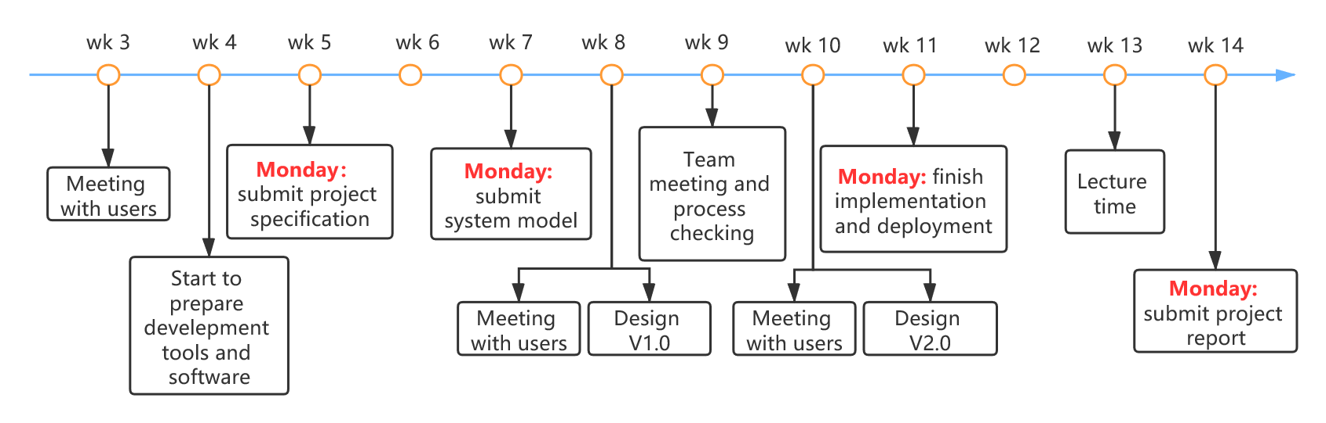

Fig. 7

## Team role

Product owner: Yanhe Lan → Sijie Min → Shaoxie Yang (Scrum sprint span: 3 weeks)

Master: Ying Sun

## Working time

48 hours per week/person.

## Software processing model

We use the Agile processing method in our project for it acts well when changes happen.

## Skills and tools

* Android studio for development
* Java for coding
* Trello for activities recording
* Zoom for team meeting twice per week to sync our project development status
* GitHub for project data repository, Java code and documents
* WhatsApp for group communication

## Reversion control

|  | Revision control | | |
| --- | --- | --- | --- |
| revision | date | description |
| 1 | V1.0.0 | 29/01/2020 | Draft version |
| 2 |  |  |  |
| 3 |  |  |  |
| 4 |  |  |  |

## Abbreviation and Acronyms

* ICDE: the Information Capture and Dissemination Environment
* TBD： to be defined

##### References

1. Ian Sommerville, Software Engineering, 10th ed., Pearson, March 24 2015.
2. Roger S Pressman and Dr. Bruce R. Maxim, Software Engineering: A Practitioner’s Approach, 8th Ed., Mcgraw-Hill Education, Jan 23 2014.
3. Ian Gorton, Essential Software Architecture, 2nd Ed., May 17 2014.